

CERTIFICATE

This is to certify that the report entitled Interactive Web-Based Platform for Visualization and Analysis of Himalayan Hydro-Cryospheric Datasets is a Bonafide work carried out by Mr. Jay Patel (23DCS076) under the guidance and supervision of Ms. Sachi Joshi for the subject CSE402 SUMMER INTERNSHIP-II of 7th Semester of Bachelor of Technology in Department of Computer Science & Engineering, DEPSTAR at Faculty of Technology & Engineering – CHARUSAT, Gujarat.

To the best of my knowledge and belief, this work embodies the work of candidate himself, has duly been completed, and fulfills the requirement of the ordinance relating to the B.Tech. Degree of the University and is up to the standard in respect of content, presentation and language for being referred to the examiner.
Ms. Sachi Joshi  Assistant Professor  Department of Computer Engineering  DEPSTAR, CHARUSAT. | 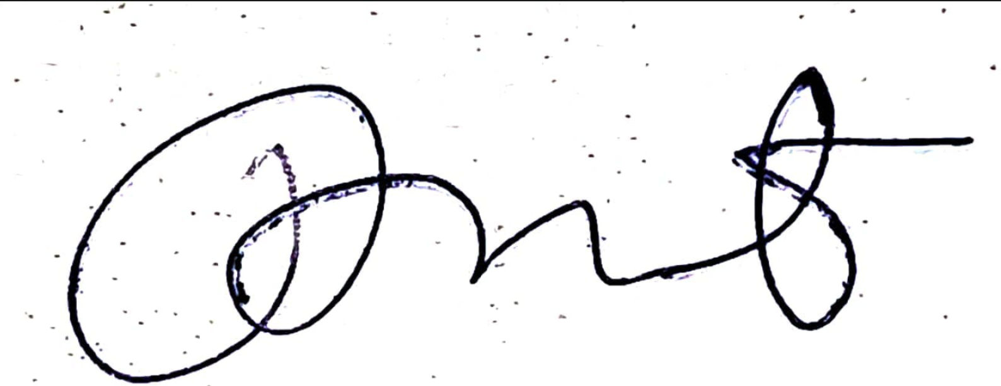  Dr. Amit Kumar Dubey  Scientist/Engineer SF  LHD/CHSG/EPSA/ISRO/SAC  Ahmedabad
Dr. Amit Nayak
Associate Professor,
Head of Department,
Department of Computer Science & Engineering,
DEPSTAR, CHARUSAT.

Devang Patel Institute of Advance Technology and Research
At: Changa, Ta. Petlad, Dist. Anand, PIN: 388 421. Gujarat

